EE204: HW 1

1)
(a)
Code:
*Ids-Vds and Ids-Vgs of a n-MOSFET
.include tsmc.txt
M1 2 1 0 0 CMOSN W=10u
VDD 2 0 DC 5v
VGG 1 0 DC 2.5V

*defining the run-time control functions
.dc VGG 0 5 0.05
*VDD 0 5 5
*.dc VDD 0 10 0.05
.control

run
*plotting input and output voltages
*plot -I(vdd)
plot deriv(-I(vdd))
*plot I(vgg) vs v(1)
hardcopy q1 deriv(-I(vdd))
wrdata q2 deriv(-I(vdd))
.endc
.end

Plot:
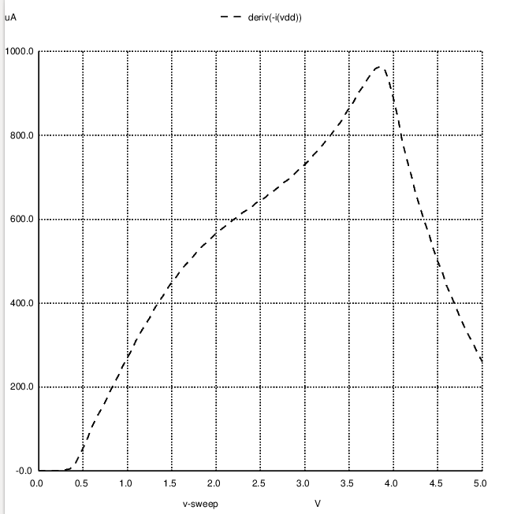

The value of maximum transconductance = 963.45uS

(b) The maxima occurs at Vgs = 3.85V.
Data points:
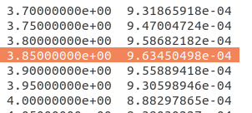

(c) Code:
*Ids-Vds and Ids-Vgs of a n-MOSFET
.include tsmc.txt
M1 2 1 0 0 CMOSN W=10u
VDD 2 0 DC 5v
VGG 1 0 DC 3.85V

*defining the run-time control functions
*.dc VGG 0 5 0.05
*VDD 0 5 5
.dc VDD 0 10 0.05
.control

run
*plotting input and output voltages
*plot -I(vdd)
plot deriv(-I(vdd))
*plot I(vgg) vs v(1)
hardcopy q1 deriv(-I(vdd))
wrdata q2 deriv(-I(vdd))
.endc
.end

Plot:
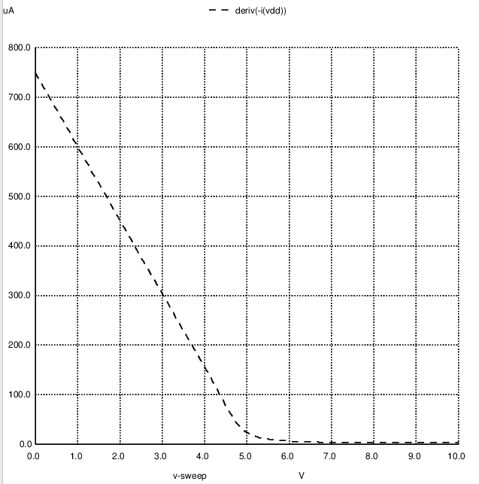

Datapoints:
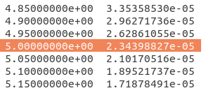

At Vds=5, 1/ r₀ = 2.344e-5, Thus, the intrinsic output resistance (r₀) = 42.66kohm
Transfer Characteristics of MOSFET:
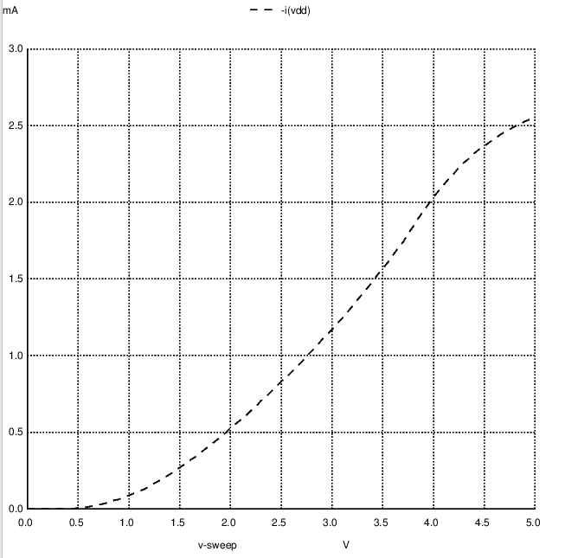
The Vt observed here is 0.5V.

Q2.
(a) code:

*Ids-Vds and Ids-Vgs of a n-MOSFET
.include tsmc.txt
M1 2 1 0 0 CMOSN W=10u
VDD 3 0 dc 15v
Vgg 4 0 dc 2.1v
Rd 2 3 19k
Vin 1 4 ac sin(0 100m 1k 0 0)
.tran 0.02m 10m
.control
run
plot (v(1)-v(4)), v(2)-4
hardcopy q1 (v(1)-v(4)), v(2)-4
.endc
.end

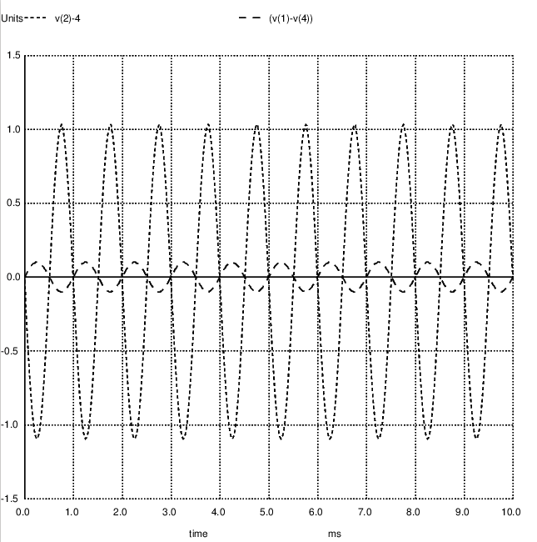

(b) Code:

*Ids-Vds and Ids-Vgs of a n-MOSFET
.include tsmc.txt
M1 2 1 3 0 CMOSN W=10u
VDD 2 0 dc 15v
Vgg 4 0 dc 14.9v
Rs 3 0 29.12k
Vin 1 4 ac sin(0 0.1 0.5k 0 0)
.tran 0.02m 10m
.control
run
plot (v(1)-v(4)), v(3)-11.17
hardcopy q1 (v(1)-v(4)), v(3)-11.17
.endc
.end

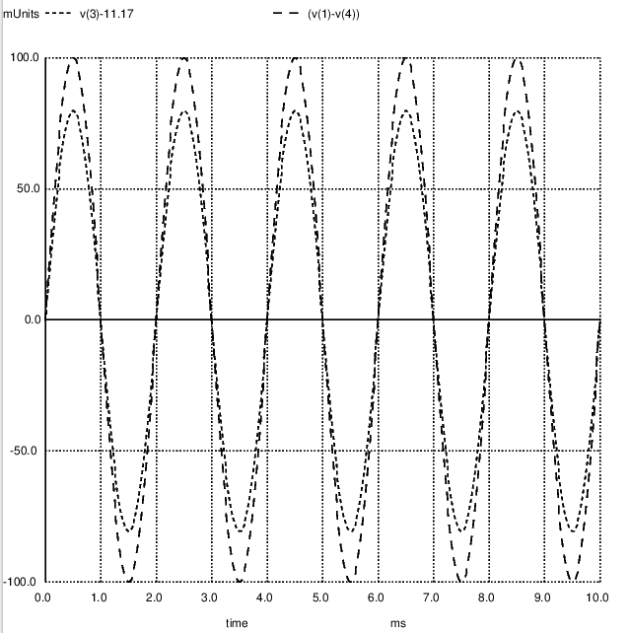

(c) Code:

*Ids-Vds and Ids-Vgs of a n-MOSFET
.include tsmc.txt
M1 2 1 3 0 CMOSN W=10u
VDD 4 0 dc 15v
Vgg 1 0 dc 2.3v
Rd 4 2 3k
Rs 3 5 1.9k
Vin 5 0 ac sin(0 0.1 0.5k 0 0)
.tran 0.02m 10m
.control
run
plot v(5), v(2)-14.085
hardcopy q1 v(5), v(2)-14.085
.endc
.end
